SET08101 Web Technologies

Assignment Part #1

Murdo Macgregor 40438627

1. **Basic summary of Detour and its’ storyline**

**Detour** is a choose-your-own-adventure browser game. The game will begin with the user driving along a quiet, dark road. Tall trees tower at either side, only parting ways to allow a cold moonlight to peer through. As the user continues down this ominous route they are forced to stop at the sight of a fallen tree, blocking the road ahead. The user will then be presented with a choice; turn around and retreat the way they came from (this ends the game), or alternatively take a small back road through the woods (this continues the game and starts the main storyline).

The story of **Detour**’s campaign follows the user on a late-night trip through a dark woodland road. As the player progresses on their journey, they may find themselves caught in differing situations - with their decisions directly affecting how the story unfolds.

1. **Background research**

For researching this project, I focused on the creative/functional side of the game; allowing for a deeper look into the technical side as construction of the website begins. I played AI Dungeon (<https://play.aidungeon.io/main/landing>) as this was the first thing that came to mind when I first read the assignment descriptor. AI Dungeon familiarised myself with exactly the kind of game I was tasked with planning, provided me with a great starting point for my own project.

1. **Planned & Potential Features**

Certain features I plan to implement require techniques & tools I have not previously used, so more research was required in those areas. One example is the **torch cursor** (see the UI examples for context). To implement this, I will be using CSS elements to change the appearance of the cursor to better suit the theme of the website. Another feature of the website planned is a **text-size changing slider**. This is crucial to allow users with lesser eyesight to use the website comfortably to whatever setup suits them the best. Yet another example of a planned feature is **colour-blind support**. I initially designed the UI conforming to a somewhat strict colour scheme, however I later realised that some colour-blind users may find difficulty navigating the website due to the colours chosen. I plan to offer a colour selection stage to the “before you play” page; this should improve any colour-blind person’s experience with the website.

1. **Initial User Interface (UI) design examples and the writer’s analysis**

The “**before you play**” page is the homepage of this website. This makes the user’s first step to set the text sizing they are most comfortable with. This setting will be applied to all the text used throughout the website for that user, giving them a personalized experience tailored to their eyesight.

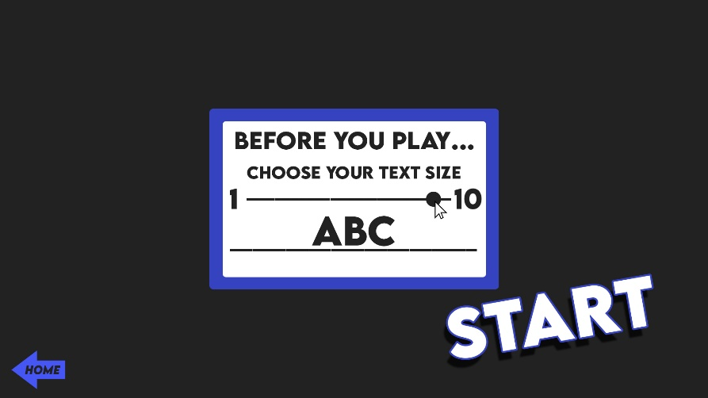

To select the desired text size, the user can use a slider ranging from 1 (smallest) to 10 (largest). This method allows for users to tweak their experience in a simple yet efficient manner while keeping the UI clean. An example of the currently selected text size is displayed below the slider, giving the user a preview of the different text sizes to assist in making the user’s experience better suited to their needs.

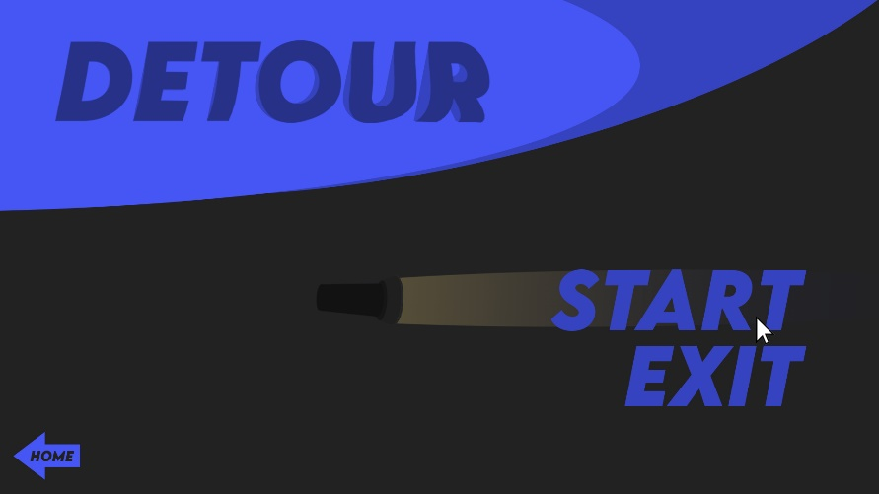

The start button is large and in clear styling to emphasise its’ importance to the user. Once clicked, the user will be sent to the “**Detour**” choose-your-own-adventure browser minigame shown below. If the “exit” text button is pressed, the game will return the user to the before you play page.

1. **Navigation Tree & Website Planning Discussion**

**End**

**Different endings dependant on previous decisions.**

Any choice made; any path taken has led to this. Multiple story endings will be available to keep the story interesting and give reason to the users’ decisions.

**Simple yet informative.**

Each page will give an idea of the character’s surroundings, providing hints and inspiration for the user’s next decision.

Text will be shown along with basic images, to keep the game interesting without sacrificing ease-of-use.

**End**

**End**

**Bulk of the storyline begins.**

Player is presented with decisions throughout the story, impacting the journey to the end of the game.

At any moment, a wrong decision could end the game.

**Start**

**Exit**

**Before You Play**